**Academic Honor Statement**

I Zaeem Yousaf 19L-1196 hereby declare that I will not use any unfair means while attempting and submitting take-home assessments e.g. quizzes, exams, etc. I will not cheat, plagiarize, or consult any other person (e.g. class fellow, senior, friend, relative, etc.) while attempting and submitting these take-home assessments. I understand that use of unfair means will result in strict disciplinary action against me. I also undertake to report approaches made by other students in violation of this honor statement to the relevant course instructor.

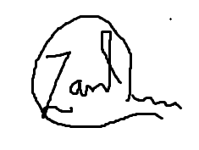

_____________________

Signature

06-06-2020

_________________________________

Date